Task on IAM
1. Create one IAM user and assign EC2 and S3 full access roles.

Here are 5 clear points describing Task 1:
- Access IAM service – Login to AWS Console and open IAM to manage users and permissions.
- Create a new IAM user – Add a user with a username and enable console access if login is required.
- Assign permissions – Choose “Attach policies directly” to give access rights.
- Attach required policies – Select AmazonEC2FullAccess and AmazonS3FullAccess to grant full control over EC2 and S3 services.
- Review and create user – Verify details, create the user, and download credentials for login and future use.

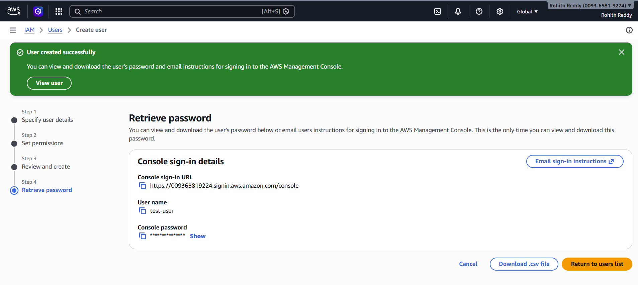

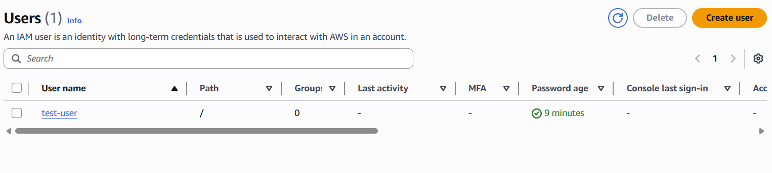
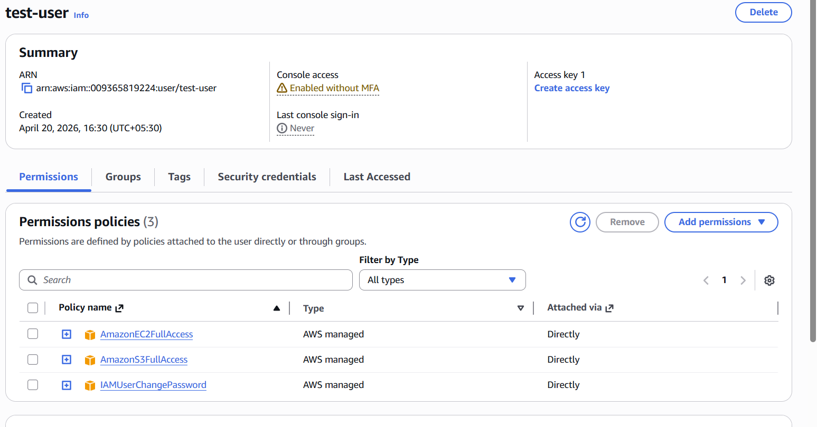

2. Create one group in IAM and assign read access for EC2.

Open IAM and navigate to User groups
Create a new group with a proper name
Attach AmazonEC2ReadOnlyAccess policy
Review and create the group
Group is ready to assign users with limited EC2 access

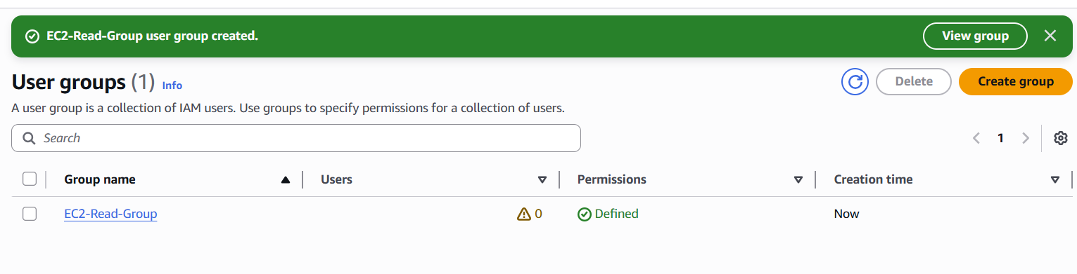

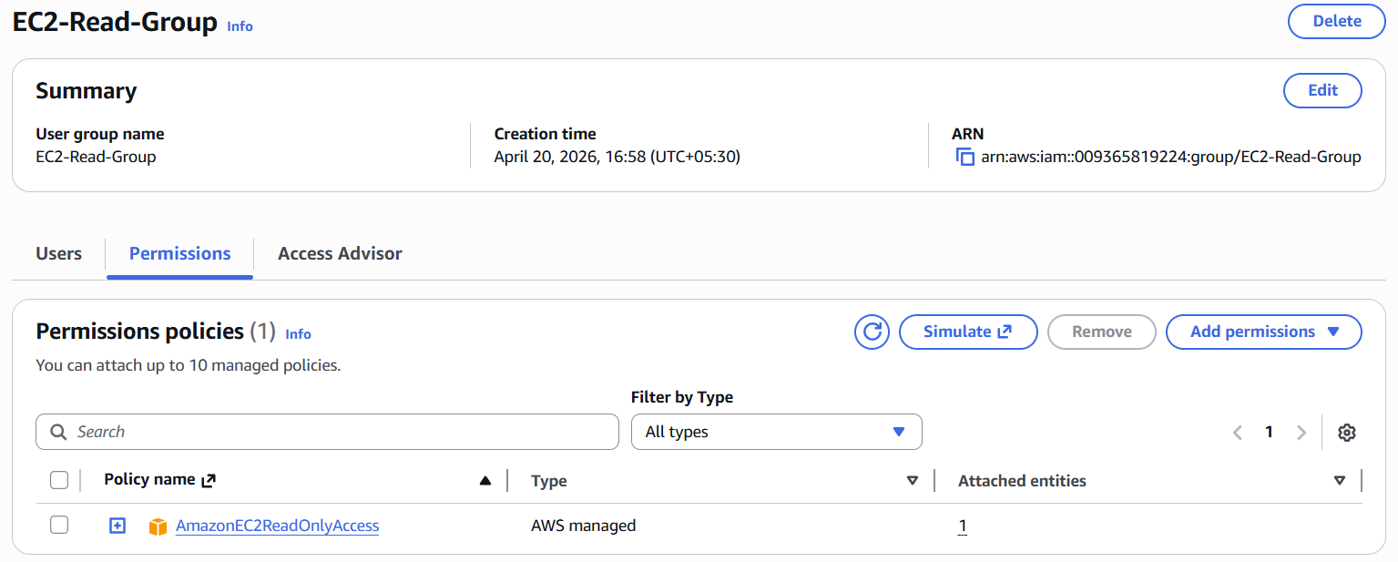
3. Create a new user named "Devops" and add to the group created in task 2.

Open IAM and go to Users
Create a new user named Devops
Choose Add user to group option
Select the existing EC2 read-only group
Create the user and verify group-based permissions

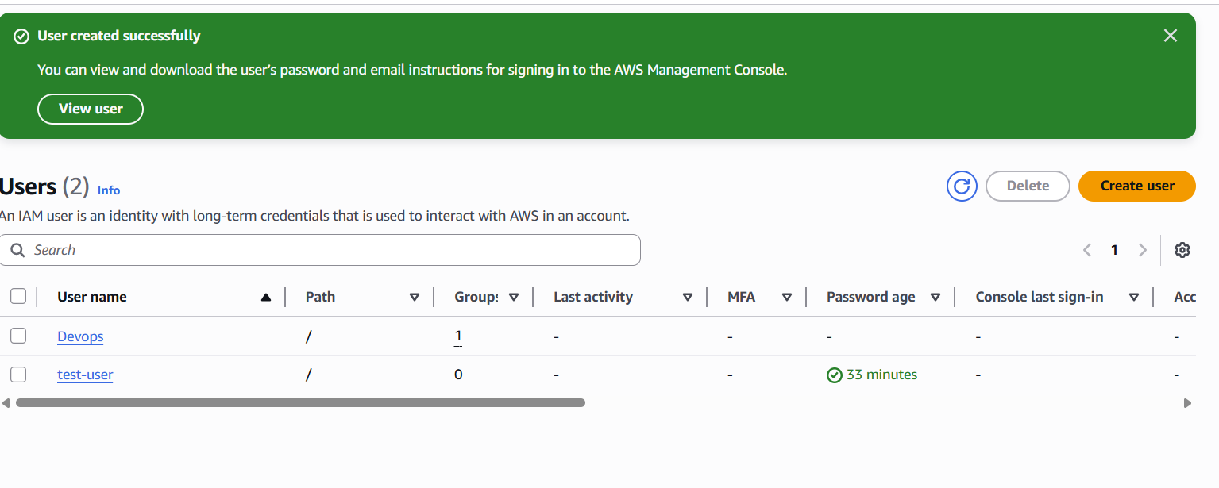

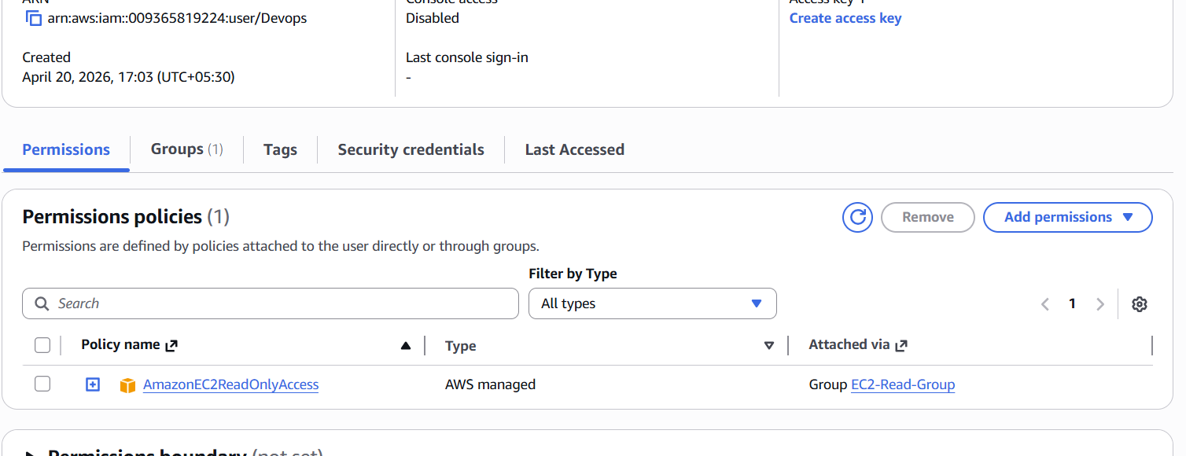

🧠 Why We Did This
- Instead of assigning permissions individually, we used a group
- Makes management easy for multiple users
- If policy changes → update group → all users get updated automatically

4. Write a bash script to create an IAM user with VPC full access.

Generate Access Key and Secret Key from IAM user under Security Credentials.
Run the aws configure command in the terminal to set up AWS CLI.
Enter Access Key, Secret Key, region (e.g., ap-south-1), and output format (json).
This configuration allows the CLI to securely connect to your AWS account.
Verify setup by running commands like aws iam list-users to check connectivity.

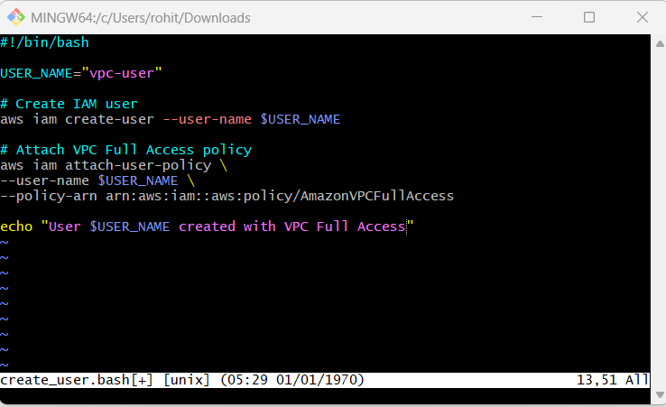

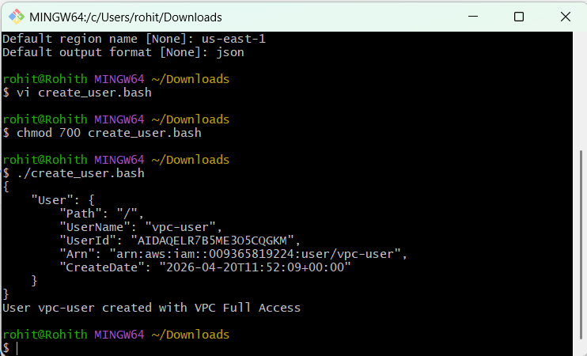
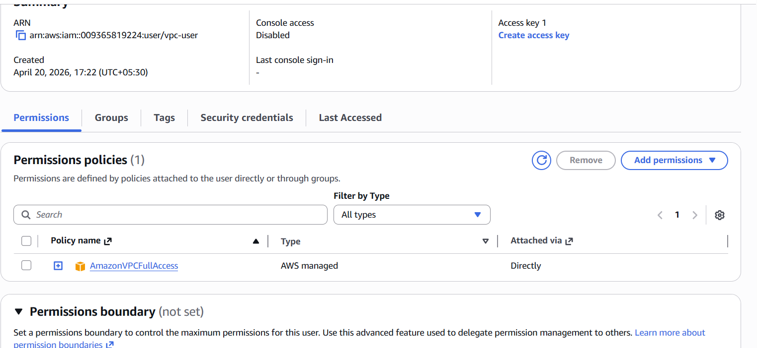

5. Create an IAM policy to allow EC2 access for a specific user in specific regions only.

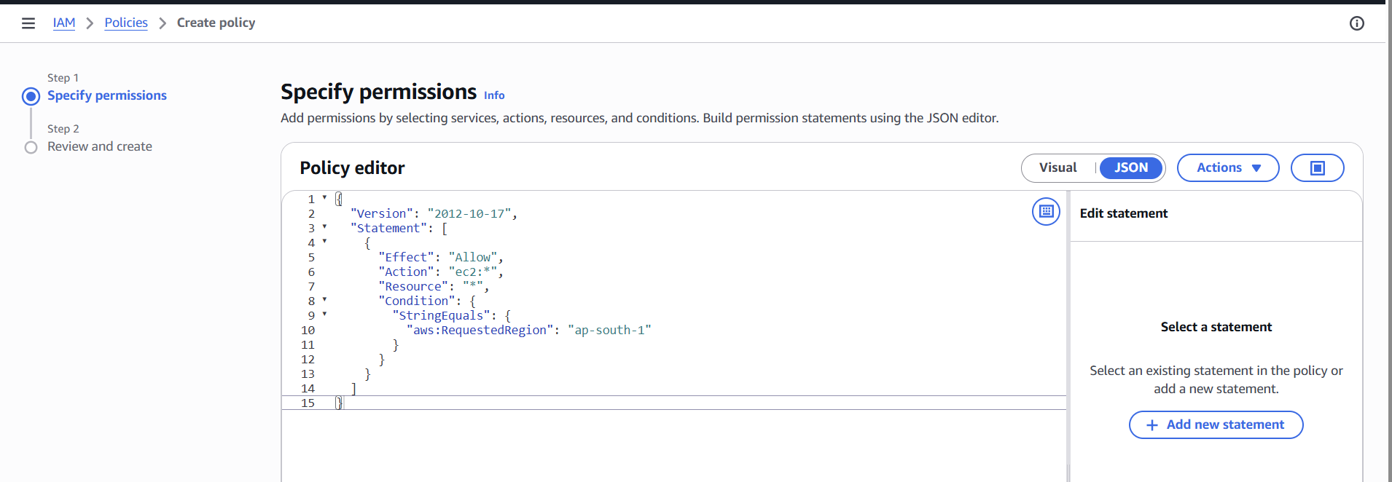

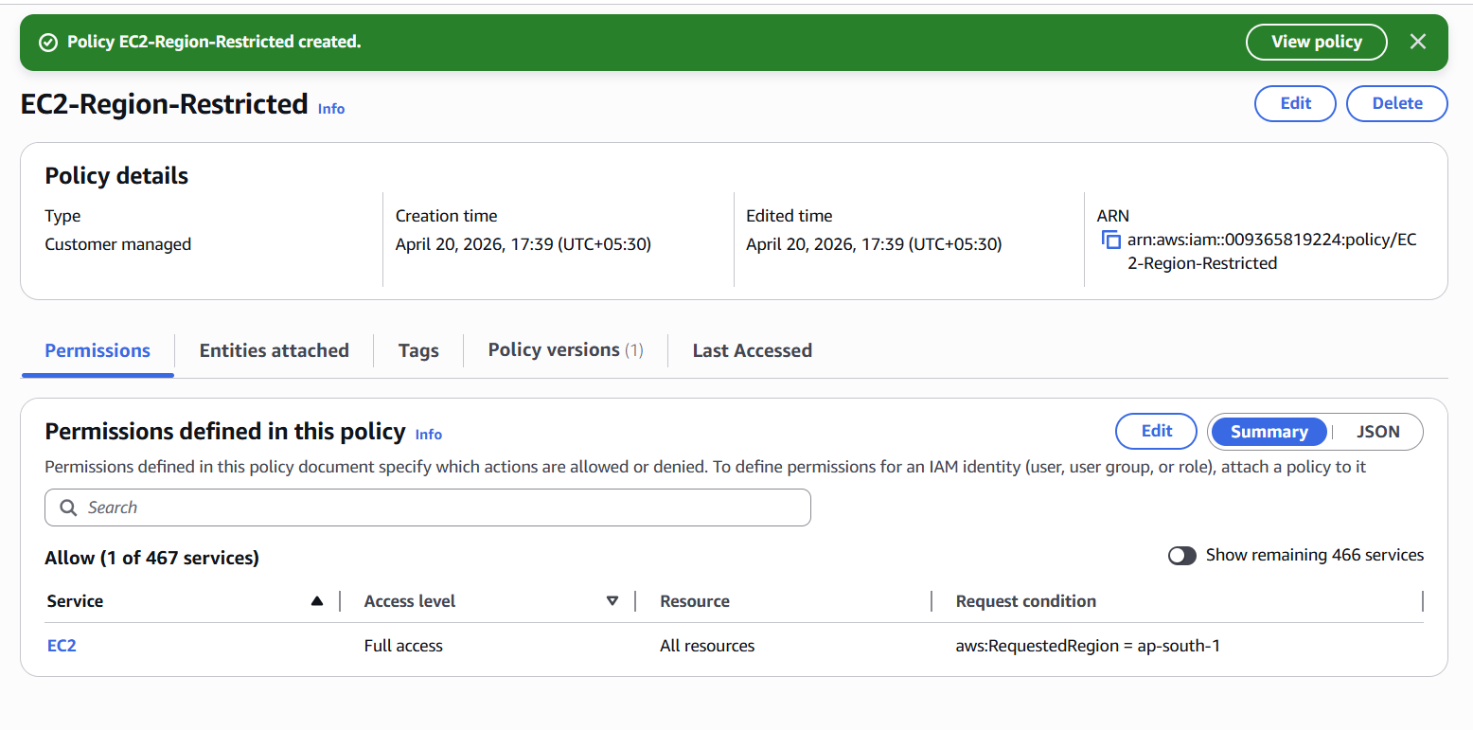
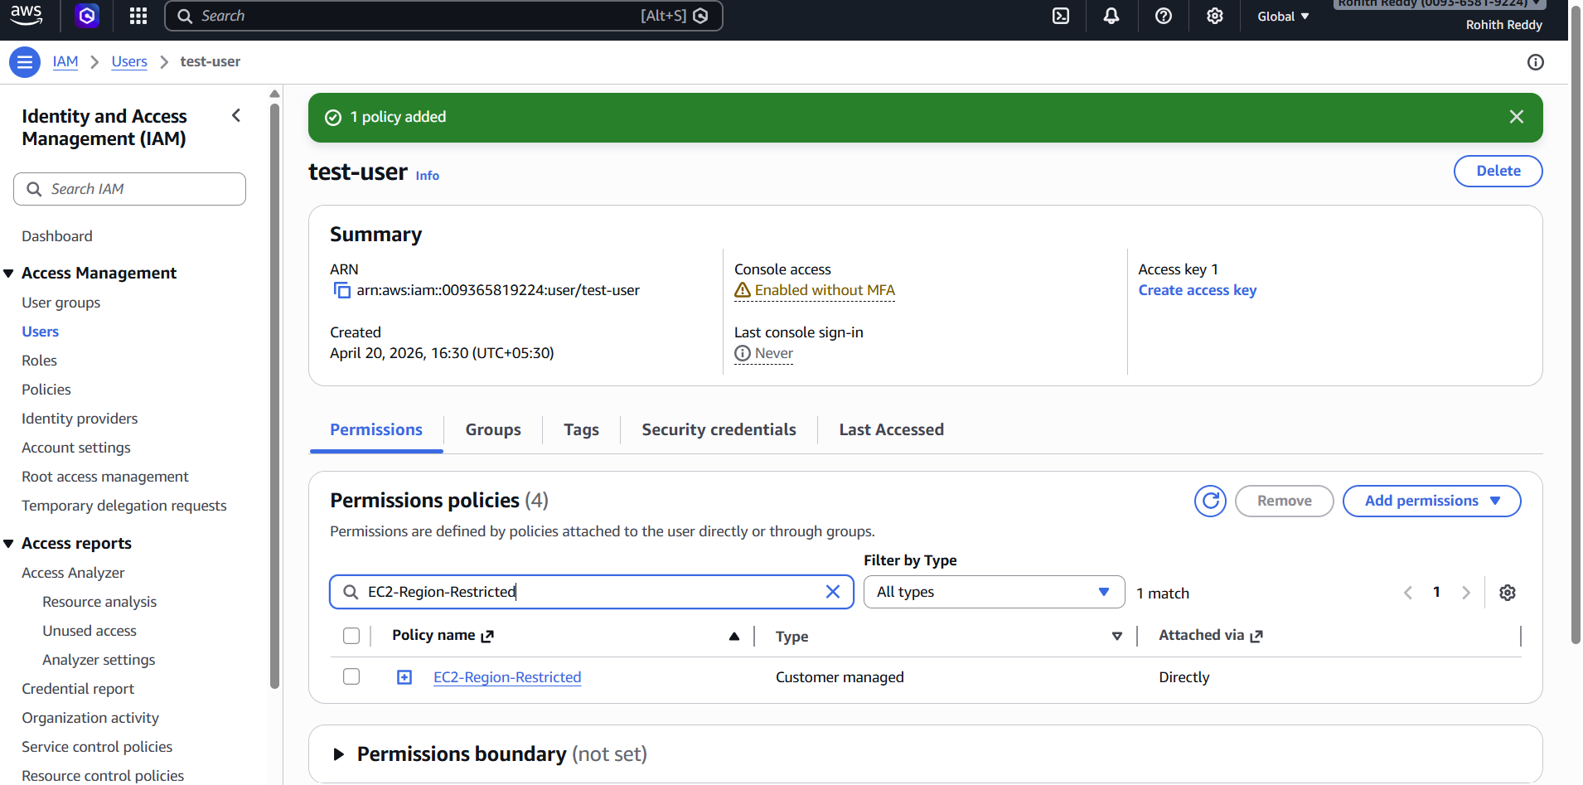

Created a custom IAM policy using JSON format.
Allowed full EC2 access using ec2:* action.
Added condition to restrict access to a specific region (ap-south-1).
Saved and created the policy in IAM.
Attached the policy to a user to enforce region-based access control.

6. We have two accounts: Account A and Account B. Account A user should access an S3 bucket in Account B.

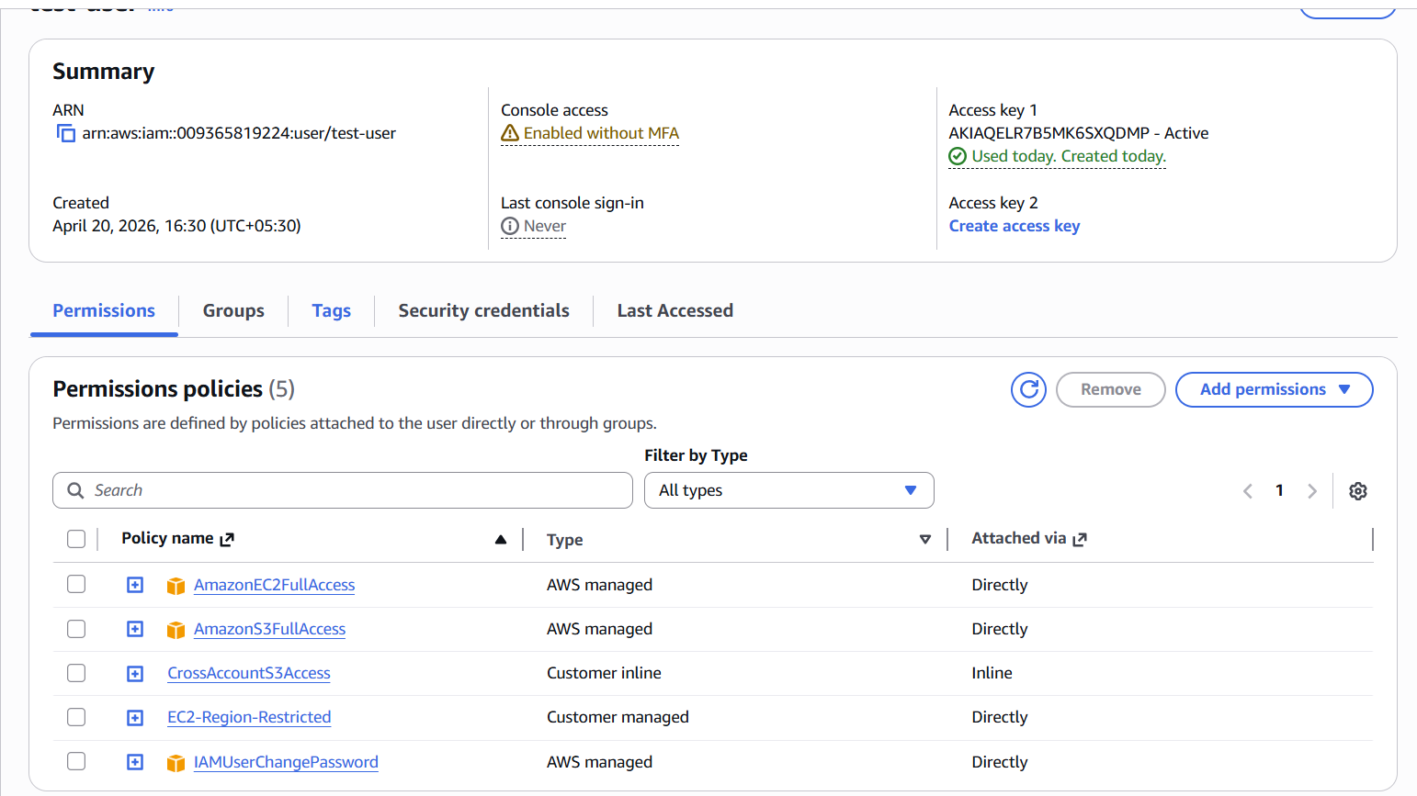

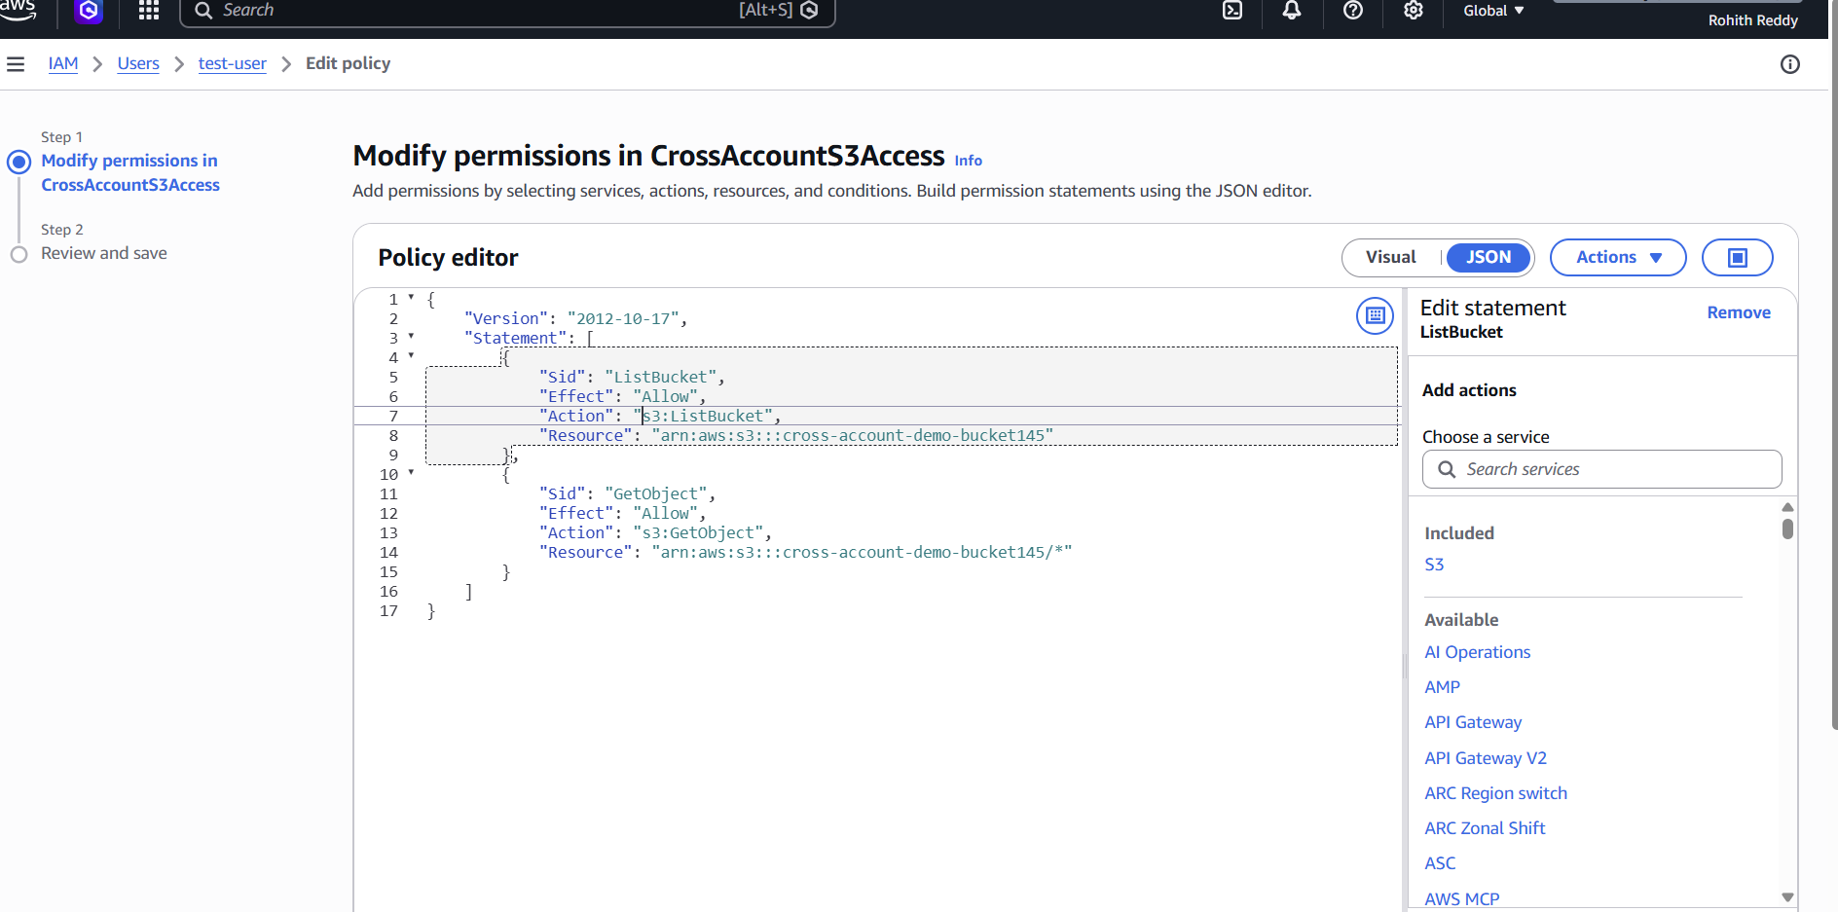

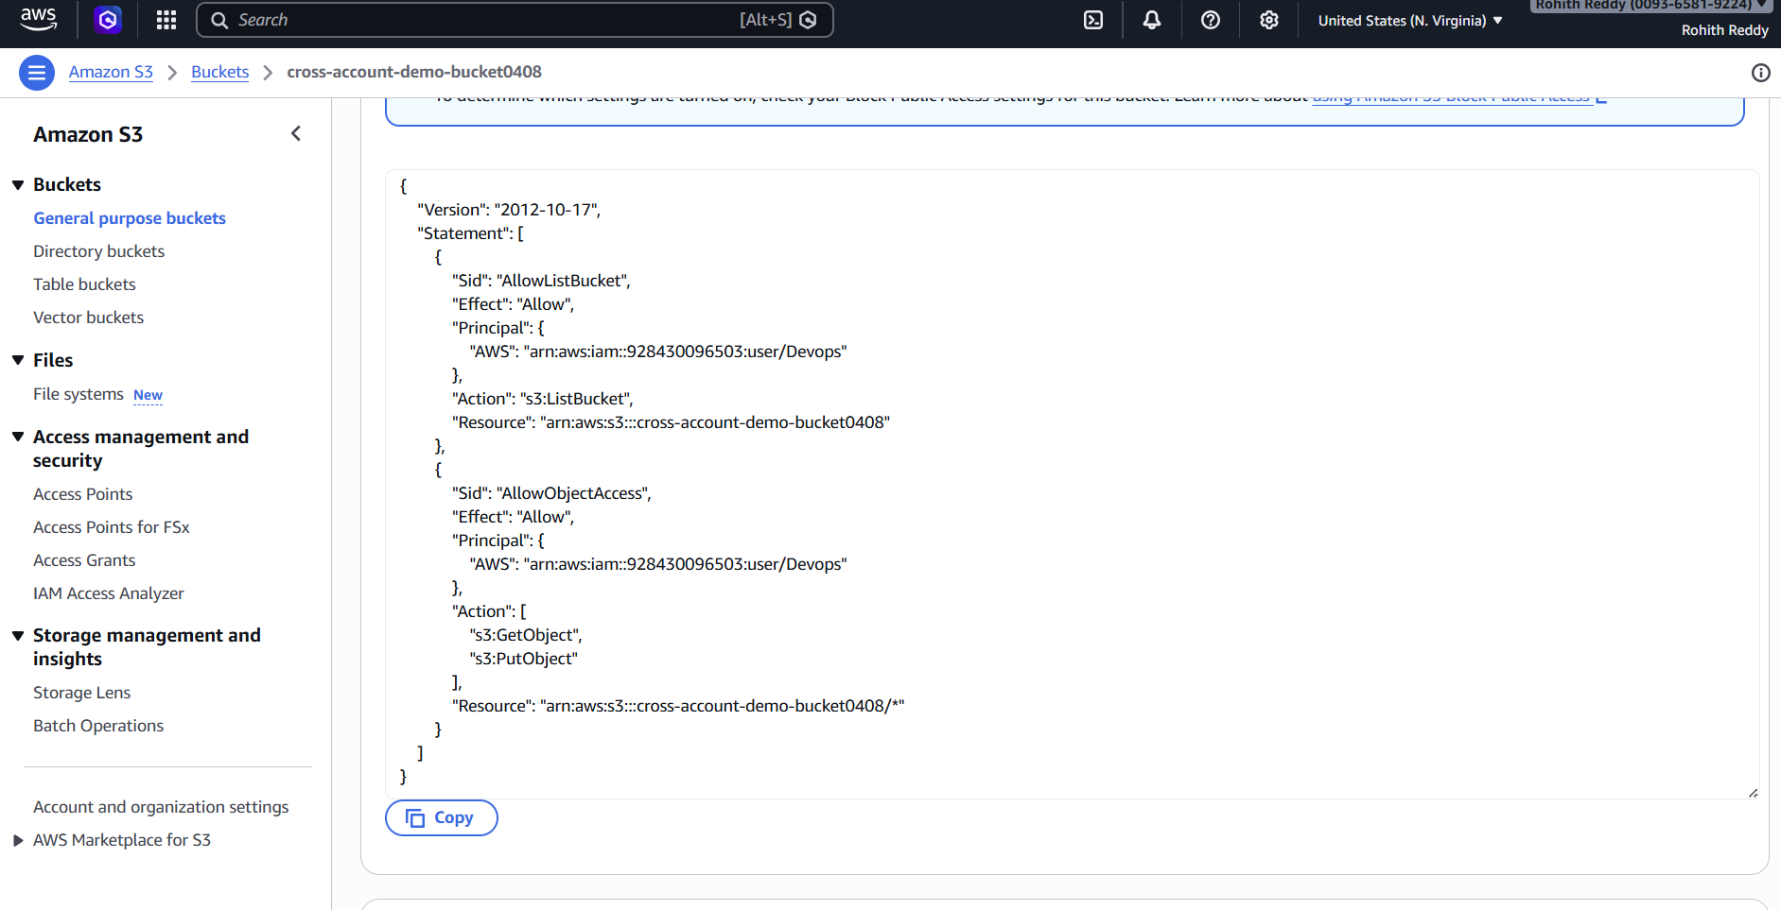

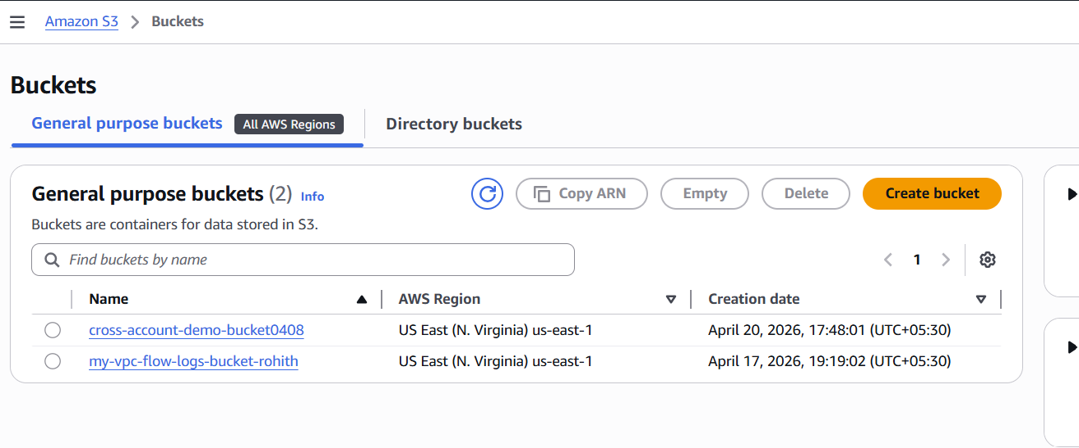

Configured cross-account access between Account A and Account B for S3.
Created an S3 bucket in Account B and added a bucket policy.
The bucket policy allows access to a specific IAM user from Account A using ARN.
In Account A, created and attached an IAM policy to allow S3 access.
Ensured correct permissions for s3:ListBucket and s3:GetObject.
Initially faced an Access Denied error while testing access via AWS CLI.
Identified that CLI was using root account credentials instead of IAM user.
Reconfigured AWS CLI using IAM user access keys.
Verified identity using aws sts get-caller-identity command.
Successfully tested cross-account access using aws s3 ls command.

